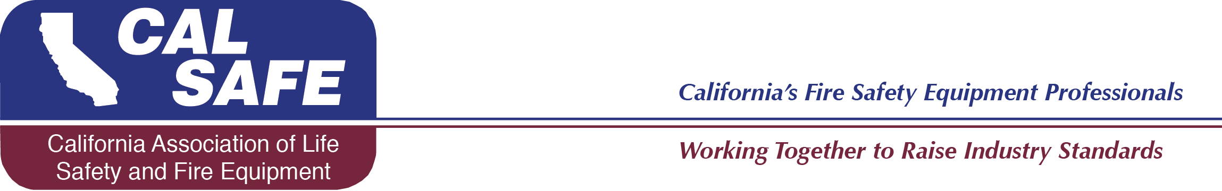

CALSAFE 25th BIRTHDAY
ANNUAL MEETING SPONSORSHIP FORM
October 4th & 5th, 2019

CALSAFE is turning 25! Many of you have asked for ways that you could help sponsor key elements of our annual meeting and we are so pleased to be able to offer the following opportunities for your sponsorship. Your sponsorship support will help create a wonderful birthday celebration, including receptions, breakfast, lunch, celebration activities and a special birthday dinner. You will be recognized as sponsors of our event, in many ways, throughout the meeting and will help share in making our meeting a great success! We appreciate your support!

Sponsorship Levels:

Platinum Level: $5000 __________

Diamond Level: $3500 __________

Gold Level: $2500 __________

Silver Level: $1000 __________

Bronze Level: $500 __________

General Meeting Sponsorships:

Conference Bags: $1000_______________________________________

Golf Sponsorships: Hole in One- $250 ___________________________

Longest Drive: $250 _______________ Closest to the Pin: $250 _______

Optional Donation: in lieu of the above $________________

Company Name:______________________________Contact:_____________________
Telephone #_____________________________email:____________________________

CALSAFE
Sponsorship
2301 ‘P’ Street
Bakersfield, CA 93301

